Risk Register

Risk management

The risk assessment process will be used by the management team to ensure risk control methods are included in all organisational planning, management of operations and governance.

Definitions

Definitions are based on the Australian and New Zealand Risk Management Standard AS/NZS 4360:2004.

Risk

The chance of something happening which will have an impact upon objectives. It is measured in terms of *consequence* and *likelihood.*

Likelihood

A qualitative description or synonym for probability or frequency.

Consequence

The outcome of an event or situation, expressed qualitatively or quantitatively, being a loss, injury, disadvantage or gain. There may be a range of possible outcomes associated with an event.

Risk assessment

The overall process of risk analysis and risk evaluation.

Risk treatment/control methods

Selection and implementation of appropriate options for dealing with risk. Conceptually, treatment options will involve one or a combination of the following five strategies

* Avoid the risk
* Reduce the likelihood of occurrence
* Reduce the consequences of occurrence
* Transfer the risk
* Retain/accept the risk.

Risk management process

The systematic application of management policies, procedures and practices to the tasks of establishing the context, identifying, analysing, evaluating, treating, monitoring and communicating risk.

**Risk assessment legend**

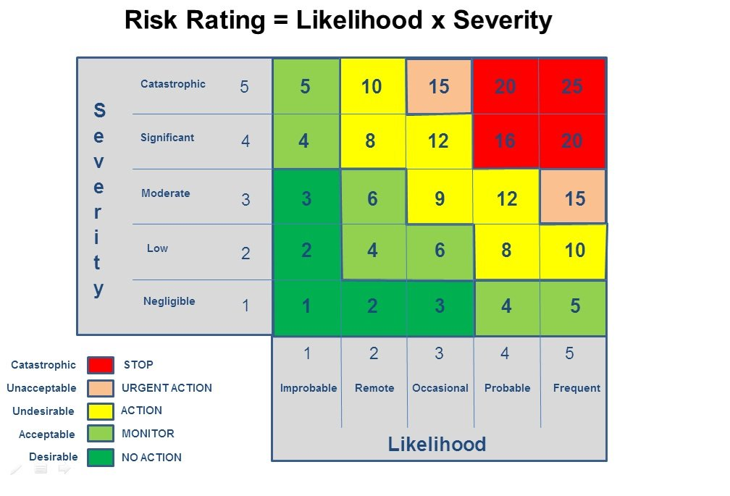

| **Area** | **Risk** | **Severity** | **Likelihood** | **Risk Rating** | **Treatment/control methods** |
| --- | --- | --- | --- | --- | --- |
| Area 1: |  |  |  |  |  |
| Area 2: |  |  |  |  |  |
| Area 3: |  |  |  |  |  |
| Area 4: |  |  |  |  |  |
| Area 5: |  |  |  |  |  |
| Area 6: |  |  |  |  |  |
| Area 7: |  |  |  |  |  |
| Area 8: |  |  |  |  |  |
| Area 9: |  |  |  |  |  |
| Area 10: |  |  |  |  |  |